# **1. Install Oracle Virtual box and create a Virtual Machine on your laptop/Desktop.**

1.1 Install Oracle Virtual box

Step 1:

Open the VirtualBox website. Go to https://www.virtualbox.org/ in your computer's Internet browser. This is the website from which you'll download the VirtualBox setup file.

Click Download VirtualBox as shown below. It's a blue button in the middle of the page. It will open the downloads page.

Step 2:

Click Windows hosts as specified below. The VirtualBox EXE file will begin downloading onto your computer.

Step 3:

Open the VirtualBox EXE file. Go to the location to which the EXE file downloaded and double-click the file. It will open the VirtualBox installation window.

Step 4:

Navigate through the installation prompts as shown in the below figure. Do the following:

● Click Next when prompted.

● Click Yes when prompted.

Step 5:

Click Finish when prompted. Make sure that you don't uncheck the "Start" box before doing this.

Step 6:

Now that you've installed and opened VirtualBox, you can create a virtual machine in order to run any operating system on your PC.

1.2 Create first VMs on your laptop/Desktop

Step 1:

To create a new virtual machine, you need to start VirtualBox.

Step 2:

Click New in the VirtualBox Manager window as shown below. The Create Virtual Machine wizard is shown, to guide you through the required steps for setting up a new virtual machine (VM)

Step 3: Name and Operating System

The following fields are available on this wizard page:

● **Name.** A name for the new VM. The name you enter is shown in the machine list of VirtualBox Manager and is also used for the virtual machine's files on disk.

● Be sure to assign each VM an informative name that describes the OS and software running on the VM. For example, a name such as Windows 10 with Visio.

● **Folder.** The location where VMs are stored on your computer, called the machine folder. The default folder location is shown.

o Ensure that the folder location has enough free space, especially if you intend to use the snapshots feature.

● **ISO Image.** Select an ISO image file. The image file can be used to install an OS on the new virtual machine or it can be attached to a DVD drive on the new virtual machine.

● **Type and Version**. These fields are used to select the OS that you want to install on the new virtual machine.

**● Skip Unattended Installation.** Disables unattended guest OS installation, even if an ISO image is selected that supports the unattended installation. In that case, the selected ISO image is mounted automatically on the DVD drive of the new virtual machine, and user interaction is required to complete the OS installation.

o The unattended installation step in the wizard is skipped.

Note :

If you don’t have an ISO Image file download it from http://releases.ubuntu.com/22.04/. Select Desktop image as shown below

Step 3.1:

Specify the Name and Select the ubuntu iso image file from your system by clicking down arrow → other….

Step 3.2:

Click the check box ‘Skip Unattended Installation’ and Click Next to go to the next wizard page.

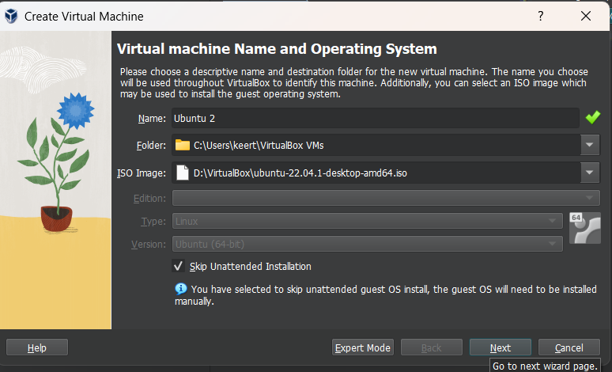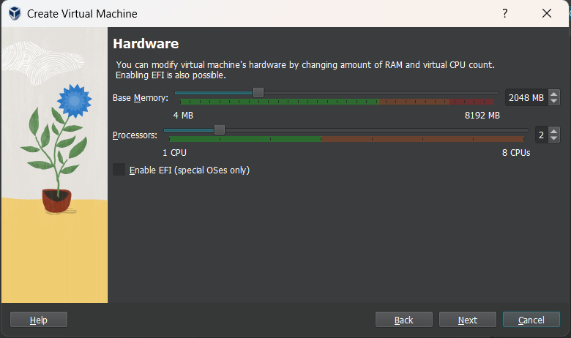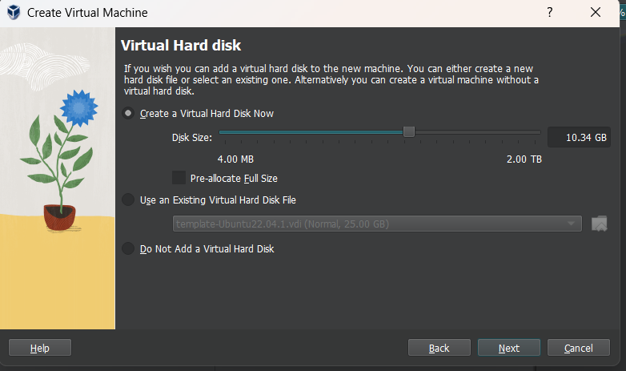

Step 4: Unattended Guest OS Install [Optional]

Use this page to set up the required parameters for unattended guest OS installation and to configure the automatic installation of the Oracle VM VirtualBox Guest Additions

The following fields are available on this wizard page:

● **Username and Password**. Enter the credentials for a default user on the guest OS.

● **Guest Additions**. Enables automatic installation of the Guest Additions, following installation of the guest OS. Use the drop-down list to select the location of the ISO image file for the Guest Additions.

● **Additional Options**. The following options enable you to perform extra configuration of the guest OS:

● **Product Key**. For Windows guests only. Enter the product key required for Windows installation.

● **Hostname**. Host name for the guest. By default, this is the same as the VM name.

● **Domain Name**. Domain name for the guest.

● **Install in Background**. Enable headless mode for the VM, where a graphical user interface is not shown.

Step 4.1:

Click Next to go to the next wizard page.

Step 5: Create Virtual Machine Wizard: Hardware

The following fields are available on this wizard page:

● **Base Memory**. Select the amount of RAM that Oracle VM VirtualBox should allocate every time the virtual machine is started. The amount of memory selected here will be taken away from your host machine and presented to the guest OS, which will report this size as the virtual machine’s installed RAM.

● **Processor(s)**. Select the number of virtual processors to assign to the VM.

Step 5.1:

Click Next to go to the next wizard page.

Step 6: Virtual Hard Disk

Use this page to specify a virtual hard disk for the virtual machine.

Step 6.1:

After having selected or created your image file, click Next to go to the next wizard page.

Step 7: Summary

This page displays a summary of the configuration for the virtual machine.

If you are not happy with any of the settings, use the Back button to return to the corresponding page and modify the setting.

Step 7.1:

Click Finish to create your new virtual machine. The virtual machine is displayed in the machine list on the left side of the VirtualBox Manager window, with the name that you entered on the first page of the wizard.

Step 8: Machine Tools

In the machine list in the left pane of the VirtualBox Manager window, select a virtual machine.

Click the Menu icon to the right of the virtual machine name. The Machine Tools menu is displayed.

# 2. Install Oracle Virtual box and create a Virtual Machine and test the communication between the guest OS and Host OS using “PING” command.

**Ex 2. Test the ping command to test the communication between the guest OS and Host OS**

**Step 1:**

Select the VM from the Machine List

**Step 2:**

Click the **Settings** icon in a toolbar at the top of the Details pane

**Step 3:**

In the Settings wizard select **Network → Adapter1 → Host-only Adapter** and click **OK** as shown below

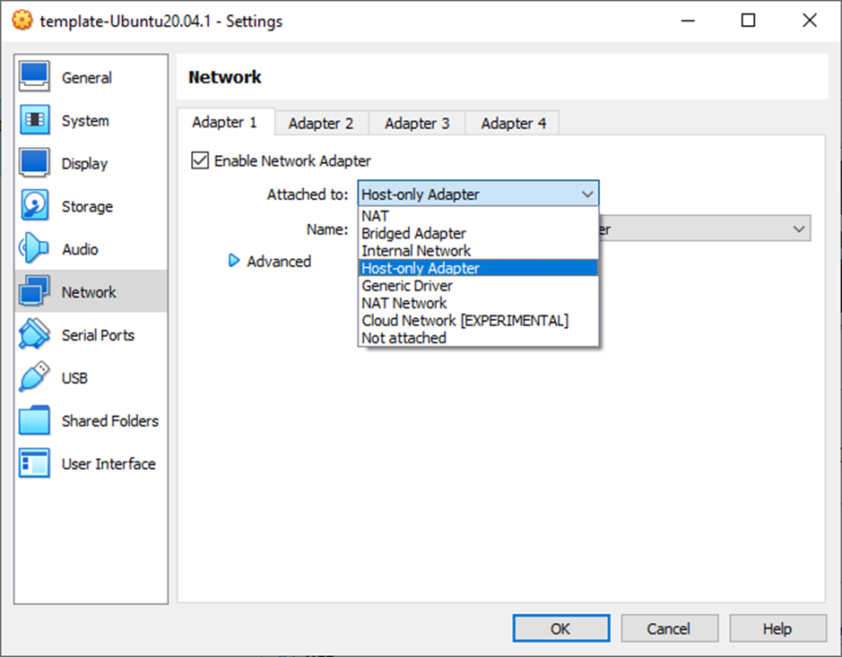

**Step 4:**

Login to the VM and run the command

**$ ifconfig**

in the terminal window as shown below and observe the IP address of the eth0 interface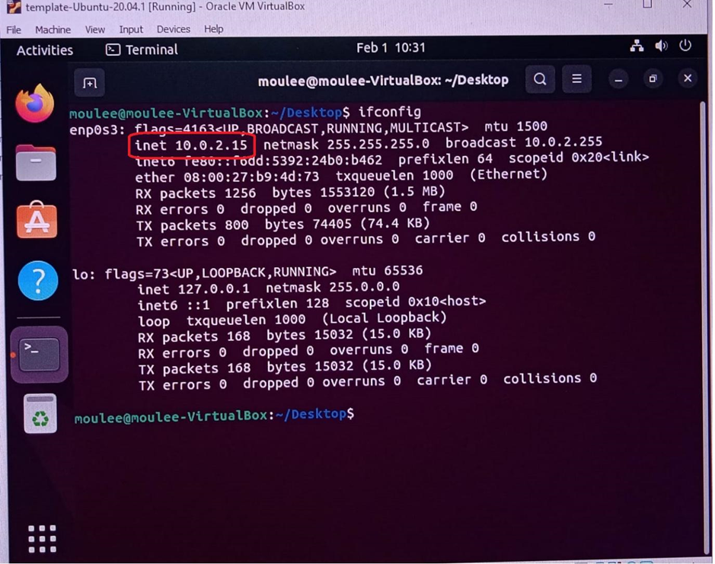

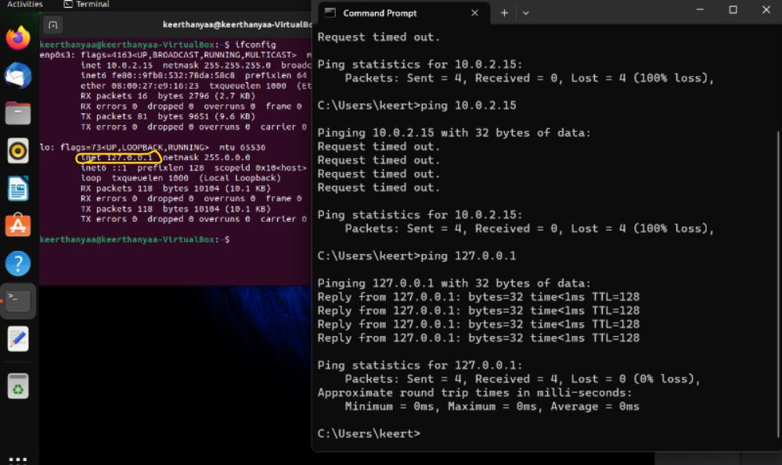

**Step 5:**

Now, ping the VM machine from the Host machine. Open the command prompt in Windows and type

| **>ping 10.0.2.15** |
| --- |

you will get the output as follows

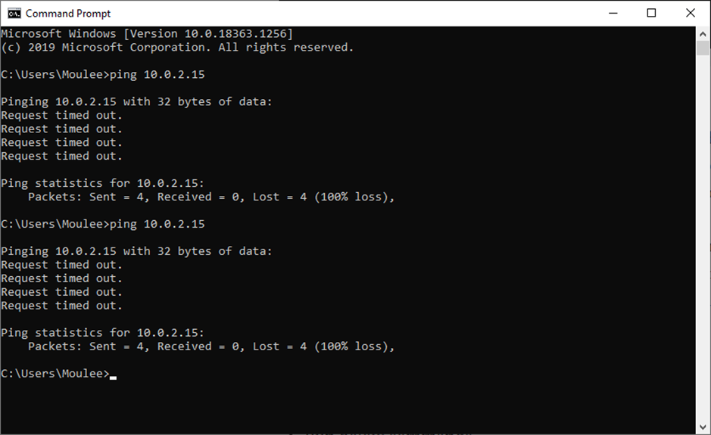

**Step 6:**

It will not work. Now, try to check the IP address of your host [Windows 10] by running the command

| **> ipconfig** |
| --- |

The output of the command is shown below. Observe that the IPv4 DNS range is different from the VM eth0 address. So, now we will assign a static IP to the VM so that both host and VM share the same DNS IP range and are able to communicate with each other

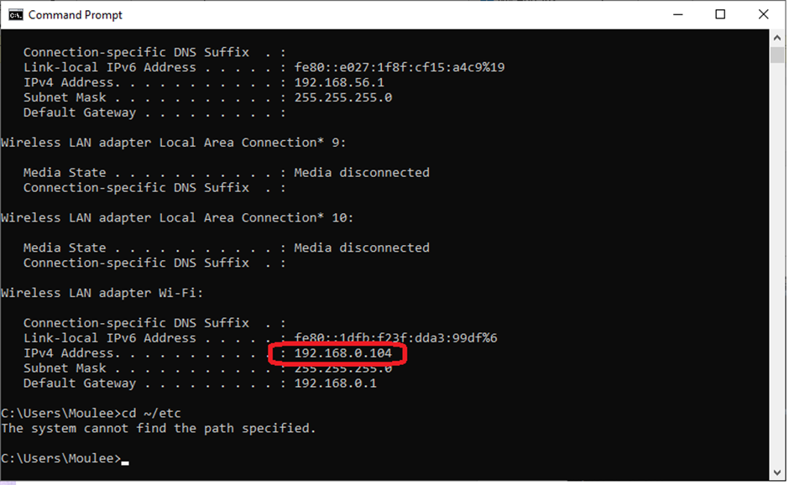

**Step 7:**

Open the terminal window in VM and run the command

| **$ cd ~/etc/netplan  $ ls** |
| --- |

There will be a file called ***01-network-manager-all.yaml.***We need to update this file with the below content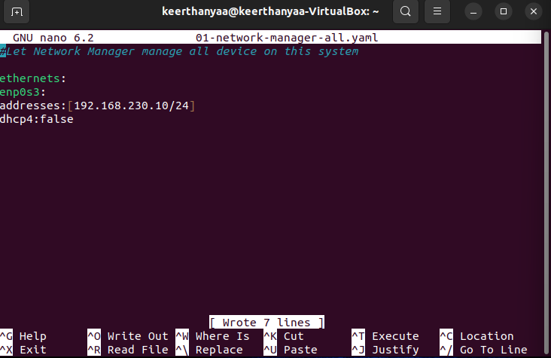

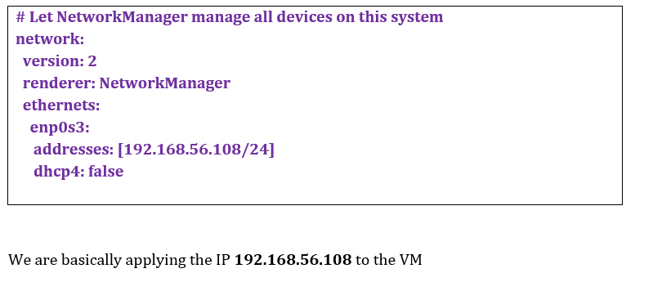

We are basically applying the IP 192.168.56.108 to the VM

Step 8:

Run the below command

$ sudo netplan apply

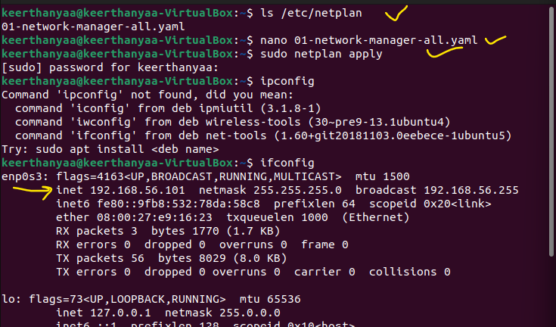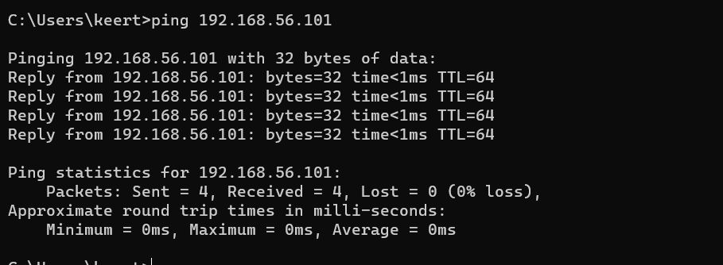

Step 9:

Go to your host machine terminal and run the command below

>ping 192.168.56.108

Most probably, you will see the output below

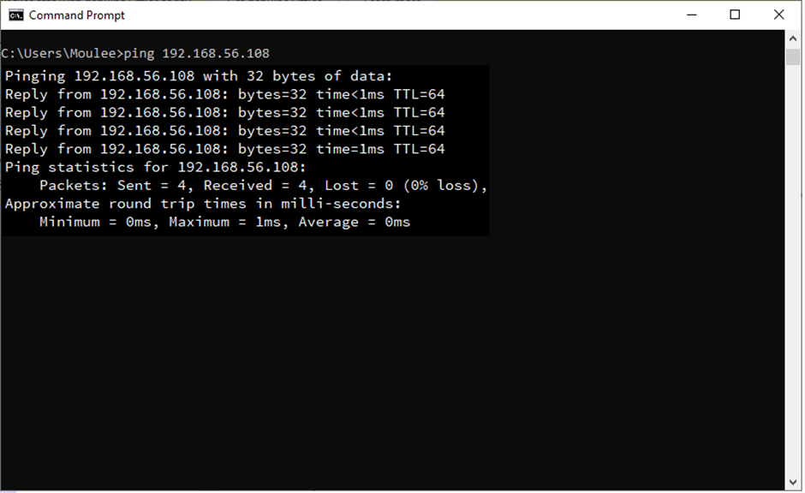

# 

# 

# 

# 

# 

# 

# 

# 

# 

# 

# 

# 

# 

# 

# 3. Create a Virtual Machine using Oracle Virtual Box and install “gcc” compiler.

**3.1 Steps to install gcc compiler**

**Step 1:**

Login to the VM

Open the terminal and type the following command and the screen shows the output

| **$sudo apt update** |
| --- |

**Step 2:**

Run the next command

| **$ sudo apt install gcc** |
| --- |

**Step 3:**

Run the command

| **$ sudo apt install build-essential** |
| --- |

**Step 4:**

Check for successful installation by executing the command

| **$ gcc - -version** |
| --- |

# 4. Write a procedure to compile C-program by splitting the programs into different modules and creating an application using “make” command

**3.2 Splitting the programs into different modules and creating an application using the make command**

**Step 1:**

Create the following files with specified names and content using the editor in Ubuntu

| **File name: mainp.c**  #include <stdio.h>  #include “functions.h”  int main()  {  display_hello();  printf(“\n\n The factorial of 5 is %d”, factorial(5));  return 0;  } |
| --- |
| **File name: functions.h**  void disp_hello();  int factorial(int n); |
| **File name: factfunction.c**  #include <functions.h>  int factorial(int n)  {  if (n!=1)  return(n * factorial(n-1));  else  return 1;  } |
| **File name: dispfunction.c**  #include <stdio.h>  #include “functions.h”  void disp_hello()  {  printf(“\nHello! Welcome!\n\n”);  } |

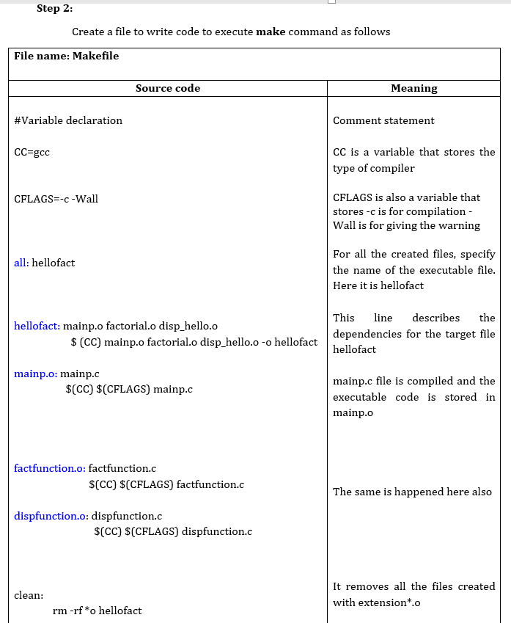

**Step 3:**

Run the following command in the terminal

| **$ make all** |
| --- |

The output of the above command is like as shown

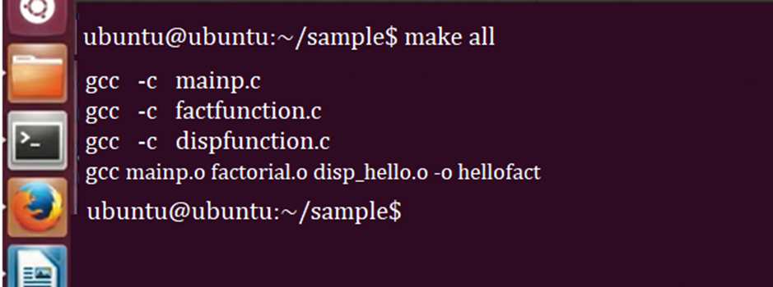

**Step 4:**

If we want to remove all the created object files with extension *.o, run the command

| **$ make clean** |
| --- |

The output is as follows

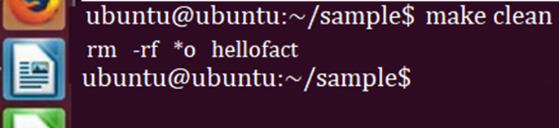

# 

# 5. Install Oracle Virtual box and create two Virtual Machines

<Just write same procedure as exp1 , but add .. a statement for 2 virtual machines >

# 6. Write a procedure to transfer the files from one virtual machine to another virtual machine.

**4. Find a procedure to transfer the files from one virtual machine to another virtual machine**

**Step 1:**

· Create two VMs

**Step 2:**

· Create NAT networks by clicking File Preferences Network

· Click on the + symbol on the rightmost edge

**Step 3:**

· Now check for the IP address of the Host OS using the command (as we discussed in Ex 2)

**>ipconfig**

· Change the CIDR address as shown below

**Step 4:**

· Select the VM

· Click **Settings ® Network ® Adapter1**

· Change **Attached to** option to **NAT Network** and **Name** as displayed in the dropdown list

**Step 5:**

· Repeat the above steps for the other VM

**Step 6:**

· Start both the VMs and note down the IPs of these machines using the command **ifconfig**

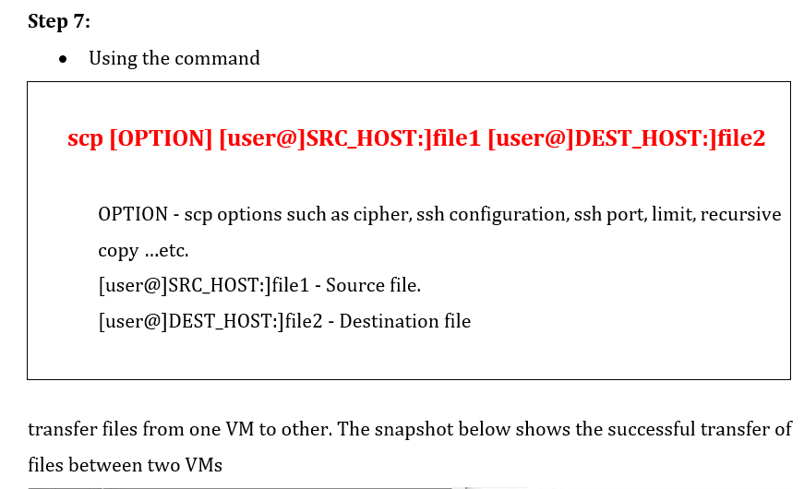

# 7. Create a central repository in GitHub and a local repository in your system and make the connection between the local repository and the central repository.

**7.2 Creating Repositories**

· The first thing is to create two repositories: a central repository and a local repository

· Now host the central repository on GitHub. For that, you need an account in GitHub and create a repository there

· For the local repository you have to install git in your system

· If you are working on a completely new project and if you want to start something fresh you can just use

**git init**

· to create your repository or if you want to join an ongoing project and if you're new to the project and you just join so you can clone the central repository using the command

**git clone**

**7.2.1 Creating Central Repository in GitHub**

**Step 1:**

· Go to github.com and if you don't have an account you can sign up for GitHub

**Step 2:**

· After creating an account sign in into account, you will find the page as shown below

· Click start a project

**Step 3:**

· Provide a repository name and the description of this repository

· Initialize your repository with the **readme**

· There might be some kind of files that you don't want when you're making operations like push or pull like some kind of log files or anything. So you can add those files in the **.gitignore** option

· Click **Create repository**

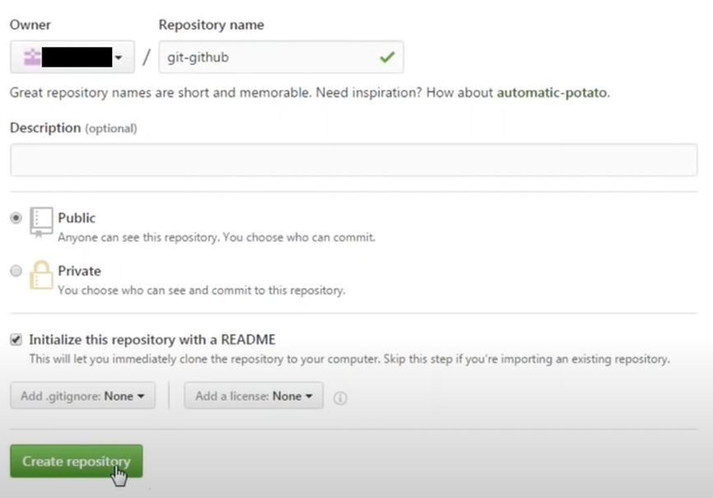

**Step 4:**

· The repository looks like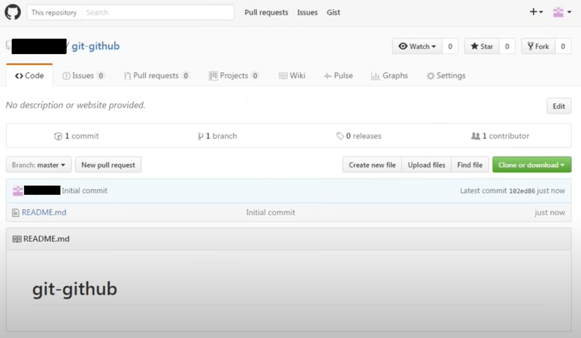

· If you want to make changes to the **readme** file just click on it as shown below

· Click on the **Edit pencil image** and make necessary changes and click the **Commit changes** button

**Step 5:**

· After committing the changes, go back to the repository you will have the following information

**7.3 Install git in local machine**

1.Browse to the official Git website: <https://git-scm.com/downloads> 2. Click the download link for Windows and allow the download to complete.

**7.3.1 Extract and Launch Git Installer**

3. Browse to the download location (or use the download shortcut in your browser). Double-click the file to extract and launch the installer.

**7.4 Creating a Local repository in the local machine**

**Step 1:**

· Create a new directory in any drive as your wish

· Open that directory and right-click ® select **Git Bash Here**

· It opens a terminal window called the git bash emulator and here type the command to create a local repository as follows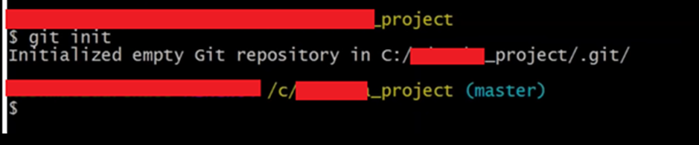

· You can see the **.git** folder created in that directory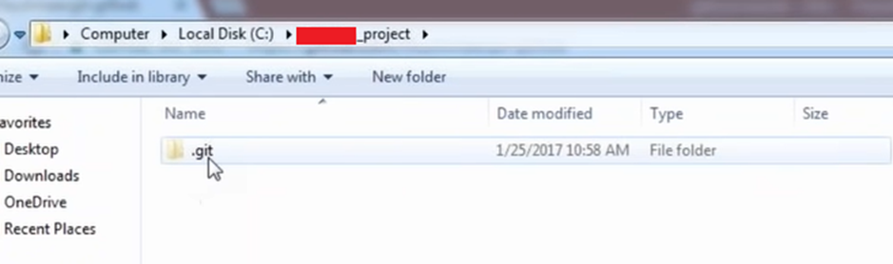

· It contains all the configurations and the object details and everything

· So, your repository is initialized and this is going to be your local repository

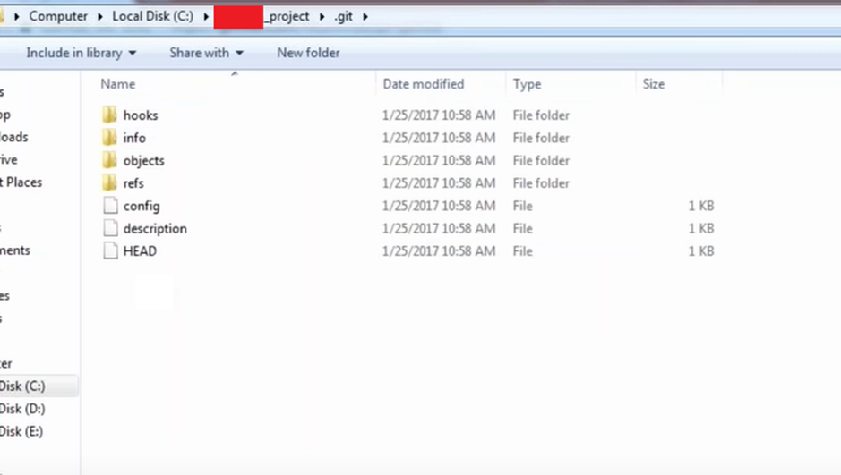

## To connect : Step 1: Create new repository

Step 2: OPen Gitbash

Step 3: Create a local project

Step 4: Initialize git repo 

Step 5: Add files in new local repo

Use git add . in your bash to add all the files to the given folder.

* Use git status in your bash to view all the files which are going to be staged to the first commit.

Step 6: Commit changes

* You can create a commit message by git commit -m 'your message', which adds the change to the local repository.

Step 7: Copy your remote repo link

### **Step 8. Add the URL copied, which is your remote repository to where your local content from your repository is pushed**

* git remote add origin 'your_url_name'

### **Step 9. Push the code in your local repository to GitHub**

* git push -u origin master is used for pushing local content to GitHub.

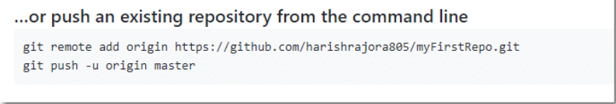

Step 10  **View your files in your repository hosted on GitHub**

# 8. Write the procedure of pulling all the files from a remote repository.

<Write exp 7 , then write git pull for next step >

The term pull is used to receive data from GitHub. It fetches and merges changes from the remote server to your working directory. The **git pull command** is used to pull a repository.

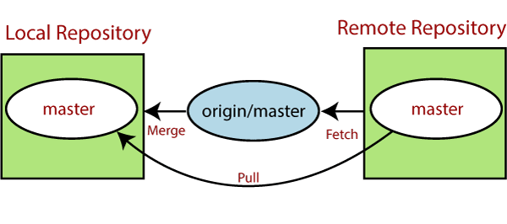

To pull all the files from a remote repository, you can follow these steps:

1. Open your command-line interface or terminal.
2. Navigate to the local directory where you want to pull the files.
3. Run the following command to initialize a Git repository if you haven't done so already:

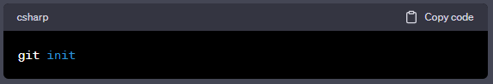

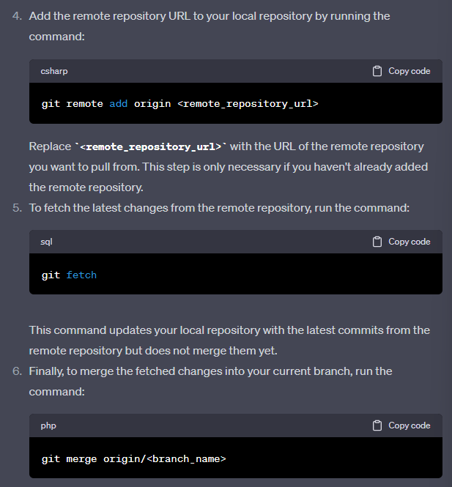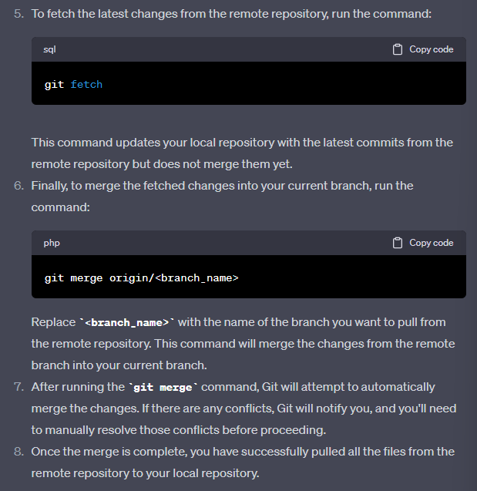

# 

# 9. Write the procedure to make changes in local repository and remote repository.

# 10. Write the procedure to clone from local repository to remote repository.

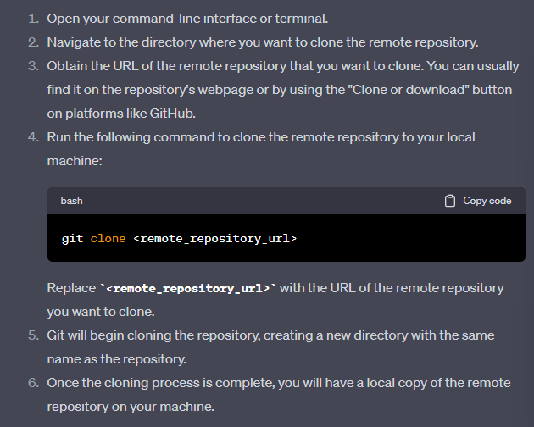

# 11. Launch a GUI application inside the Docker Container

# 12. Write a procedure to access the application from the Docker Host system.

# ~~13. Using a Simple code, implement a Ecommerce webpage using appropriate web tools~~

# ~~14. Create a simple Personal blog which should detail your academic proficiency, skill sets, personal interests using appropriate Web tools (XAMPP Server can be used if required)~~

# 15. Write a procedure to launch an EC2 instance and connect to it using the AWS Management Console

Write a procedure to launch an EC2 instance and connect to it using the AWS Management Console

1. Go to the AWS Management Console, select a region, and choose EC2 under Services.
2. Choose Launch instances, select an AMI, and choose an instance type.
3. Configure the instance details, add storage, add tags, and configure the security group.
4. Choose Launch, create or select a key pair, and download the private key file.
5. Choose Launch Instances and View Instances to see the status of your instance.
6. Wait until the instance state is running and the status checks are passed.
7. Find the public IPv4 address of your instance from the Instances page.
8. Change the permissions of your private key file to 400 using chmod command on your local machine.
9. Connect to your instance using ssh command with your private key file and public IPv4 address.
10. Confirm the identity of the host and enjoy your instance.

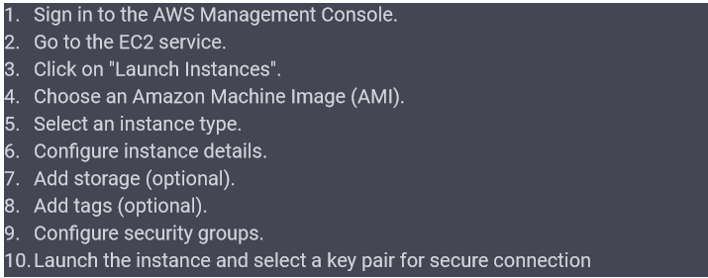

# 16. Write a procedure to develop an application using Google App Engine to display the text as you wish.

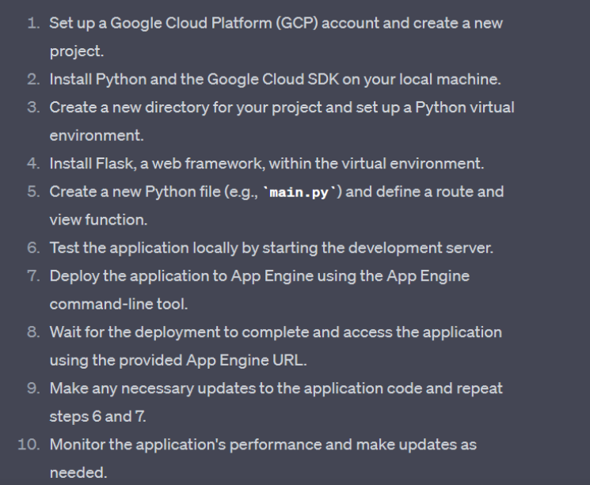

# 17. Write a procedure to develop an application using Windows Azure to display the text “Hello World”.

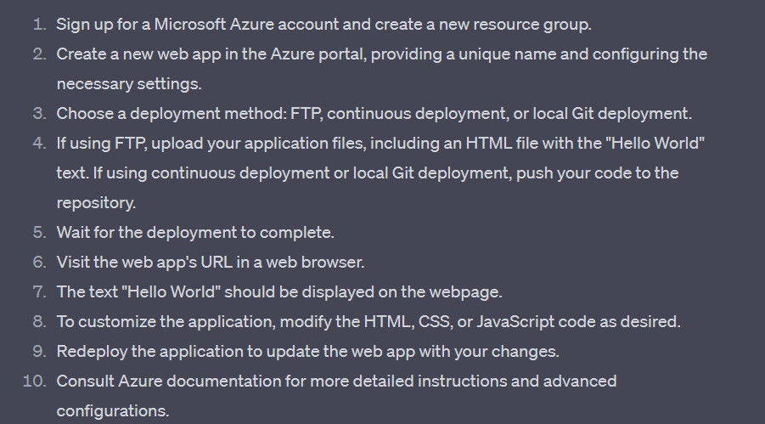

# 18. Write the procedure to configure a XAMPP Server for enabling web application and development.



 

 

 

 

 